System VB6 ocx and dll tests
- Base VB test This tests that the required VB system files are valid
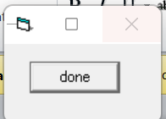
- ADO test This tests that the required ADO system files are valid
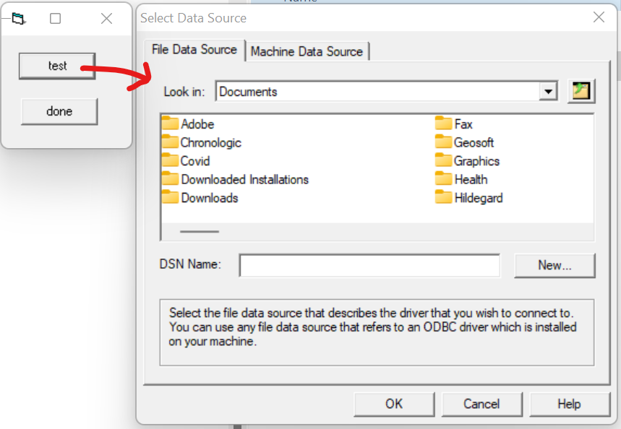

- DAO test This tests that the required DAO system files are valid
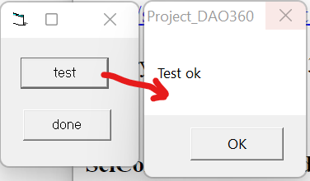

- Cmdlg test This tests the operation of the cmdlg32.ocx
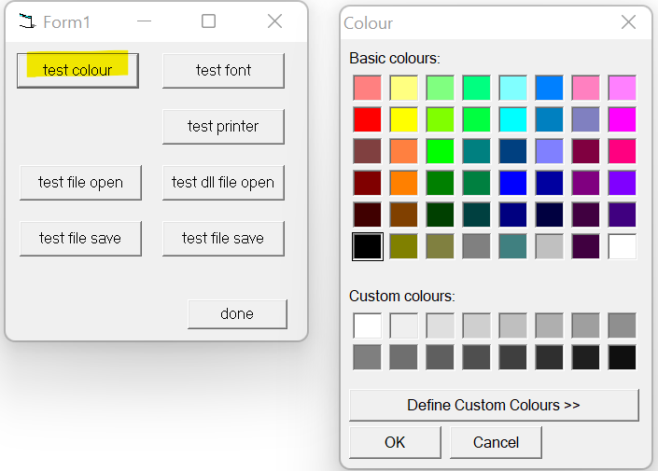
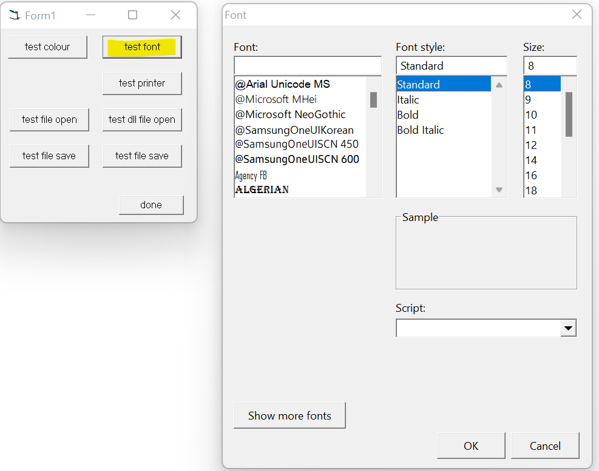
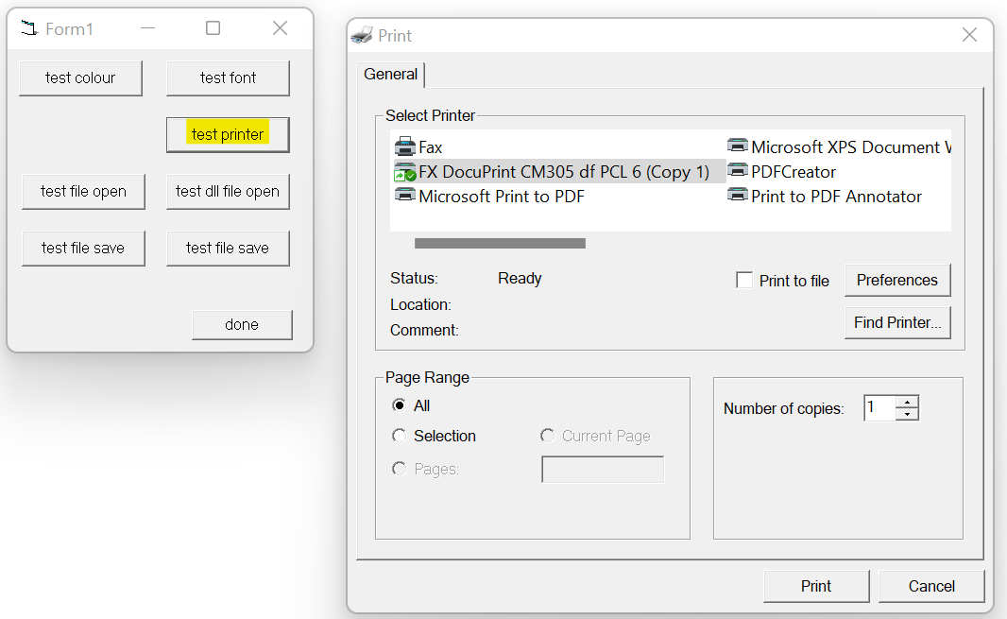
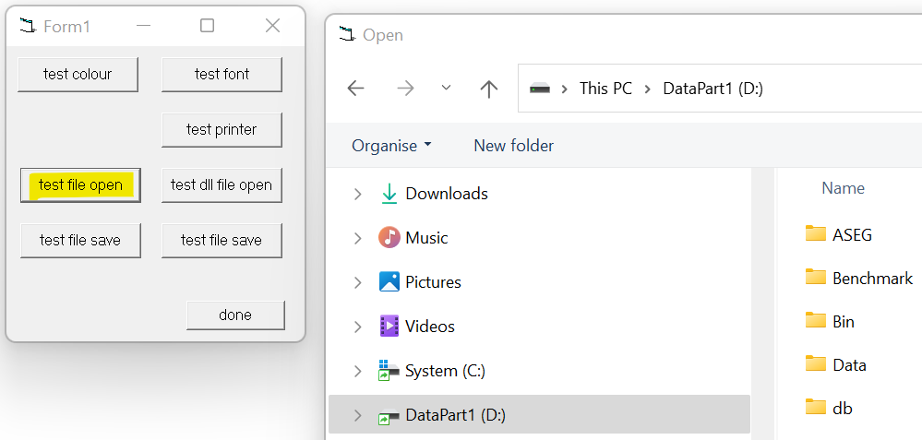
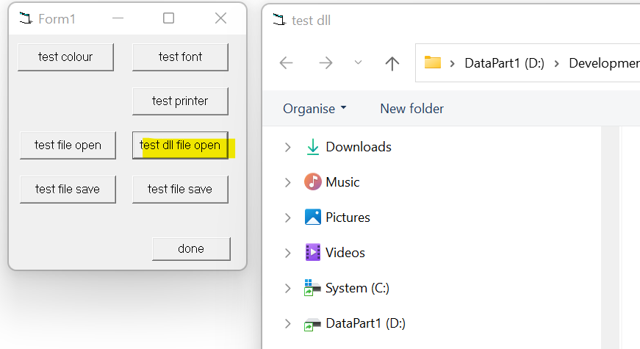
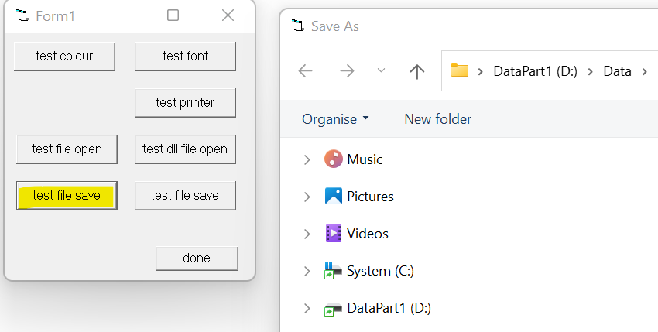
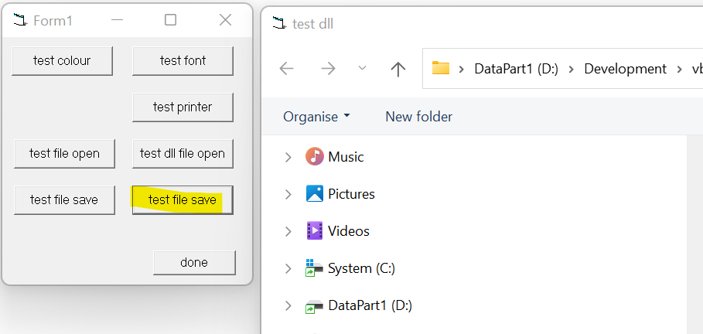
- MScomct2 test This tests the operation of the MScomct2.ocx
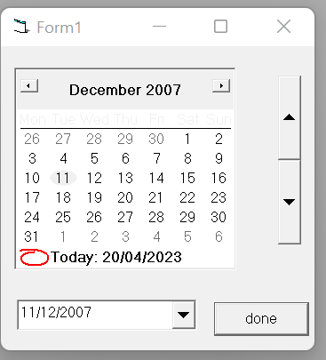
- MScomctl test This tests the operation of the MScomctl.ocx
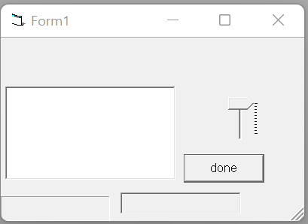
- MSflxgrd test This tests the operation of the MSflxgrd.ocx
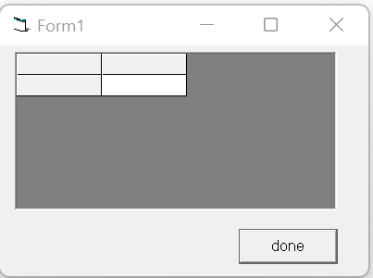

- Graph32 test This tests the operation of the graph32.ocx
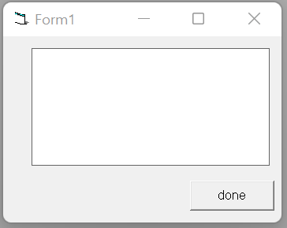

- Grid32 test This tests the operation of the grid32.ocx
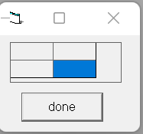
- Richtx32 test This tests the operation of the richtx32.ocx
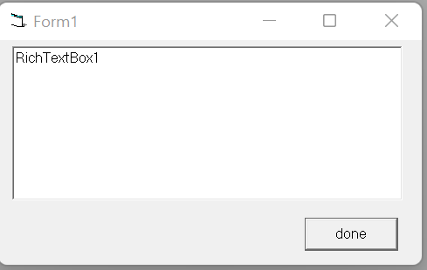
- Scrrun test This tests the operation of the scrrun.dll
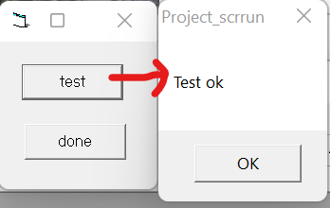
- Spin32 test This tests the operation of the spin32.ocx
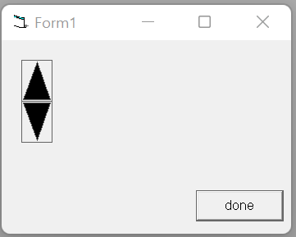
- Tabctl32 test This tests the operation of the tabctl32.ocx
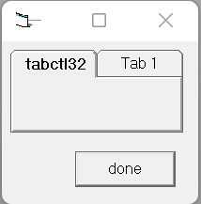
- Threed32 test This tests the operation of the threed32.ocx
